**Assignment No : 5**

1. Write a query that will give you all orders for more than Rs. 1,000.

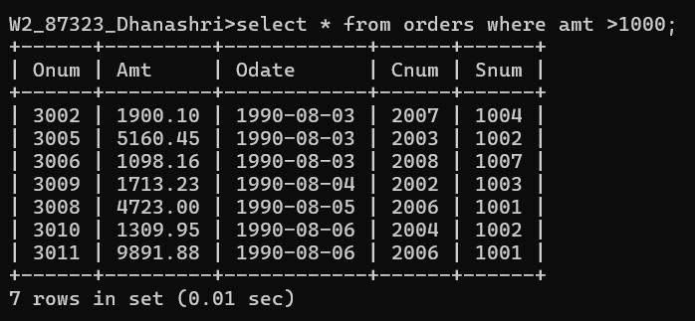

1. Write a query that will give you the names and cities of all salespeople in London with a commission above 0.10.

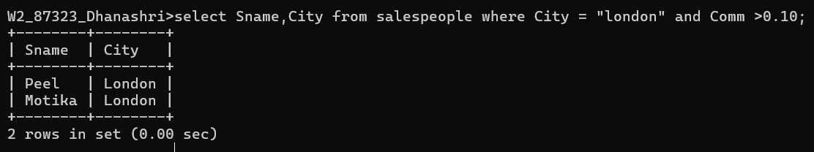

3) Write a query on the Customers table whose output will exclude all customers with a rating <= 100, unless they are located in Rome.

4) What will be the output from the following query?

Select * from Orders

where (amt < 1000 OR

NOT (odate = ‘1990-10-03’ AND cnum > 2003));

5) What will be the output of the following query?

Select * from Orders where NOT ((odate = ‘1990-10-03’ OR snum>1006) AND amt >= 1500);

6) What is a simpler way to write this query?

Select snum, sname, city, comm From Salespeople where (comm > .12 OR comm <.14);